**Advance Excel Assignment 3**

1. How and when to use the AutoSum command in excel?

**Solution:**

* To sum a number of columns or rows, we use AutoSum function.
* Select the cell next to the number you want to sum, click Auto Sum on the Home tab, and press Enter to complete. When you click Auto Sum, Excel will automatically enter the formula (using the SUM function) to sum the numbers.

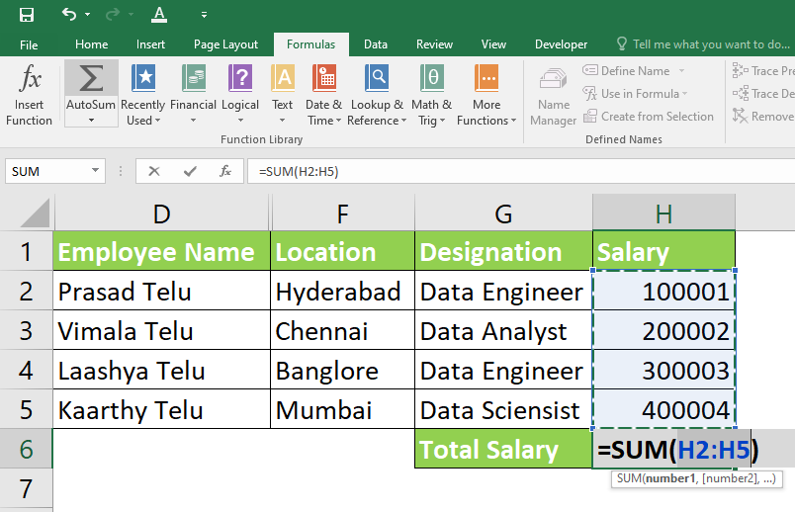

1. What is the shortcut key to perform AutoSum?

**Solution:**

The Autosum Excel function, accessible by entering the shortcut **ALT + =** symbol in a spreadsheet, automatically creates a formula that sums all the numbers in a contiguous range.

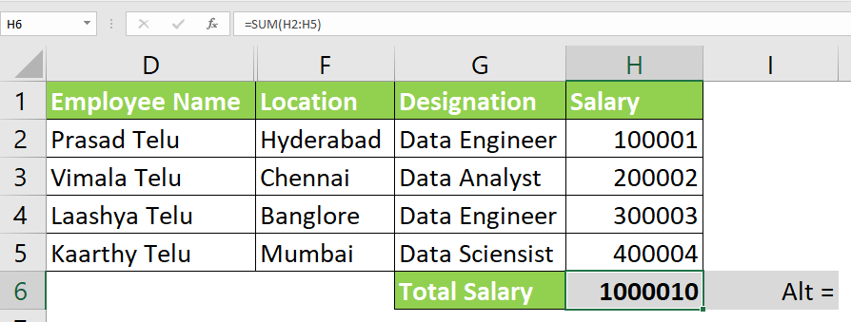

1. How do you get rid of Formula that omits adjacent cells?

**Solution:**

Excel formulas omit adjacent cells. Mathematical or statistical functions such as SUM, AVERAGE, COUNT, MIN, and MAX can cause errors.

This error occurs when no cell with the same value as the selected cell is selected. Excel recognizes it as an error and symbolizes it with a small triangle.

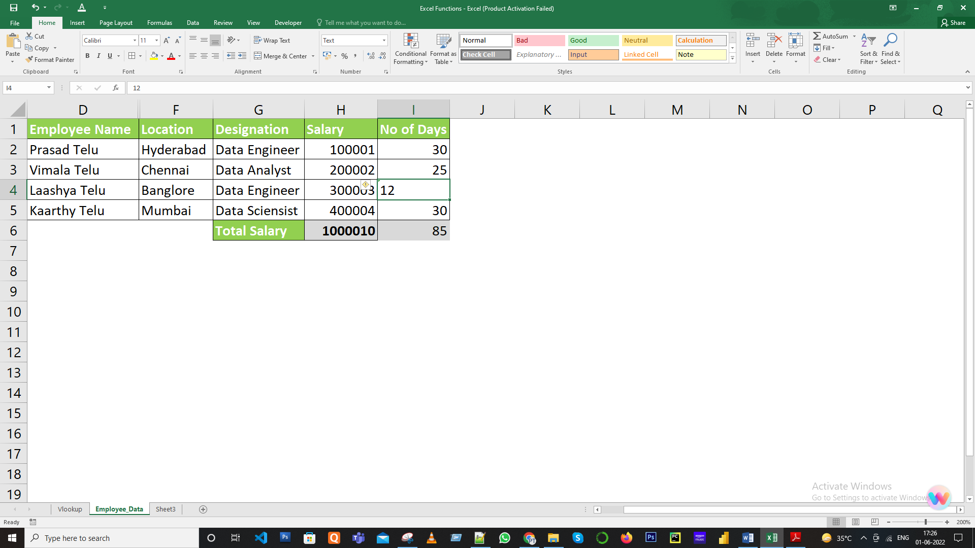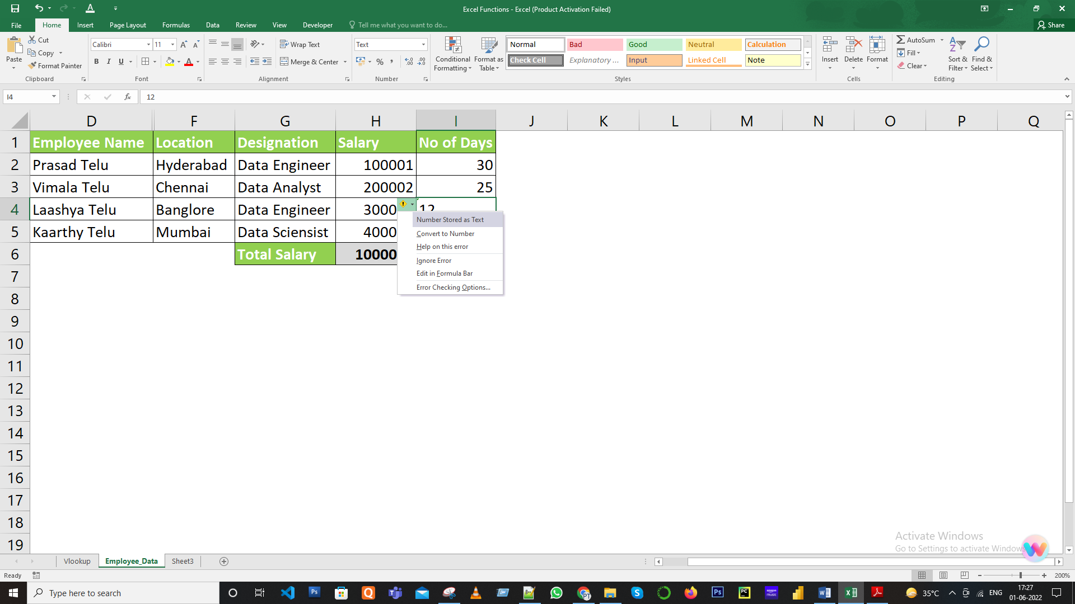

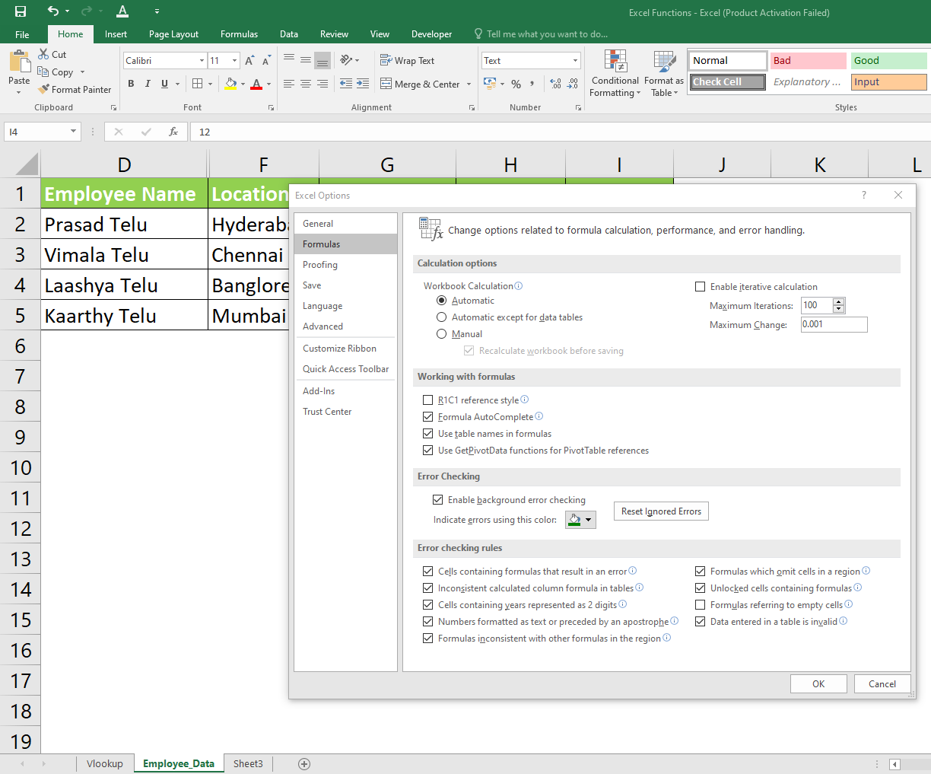

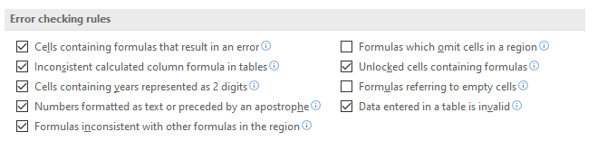

And Click Ok button.

1. How do you select non-adjacent cells in Excel 2016?

**Solution:**

There are two ways to select the non-adjacent cells in Excel, either by mouse or keyboard.

**Using Mouse**

In addition to the mouse, you will also need a computer keyboard to select one or more

Rows and columns.

* Click the cell.
* Press the Ctrl key on your keyboard. Press it while you are Selecting a cell.
* Hold down the left mouse button and drag to the required cell Choose.
* Keep repeating these steps for each cell. It`s an easy way to select non-adjacent cells.

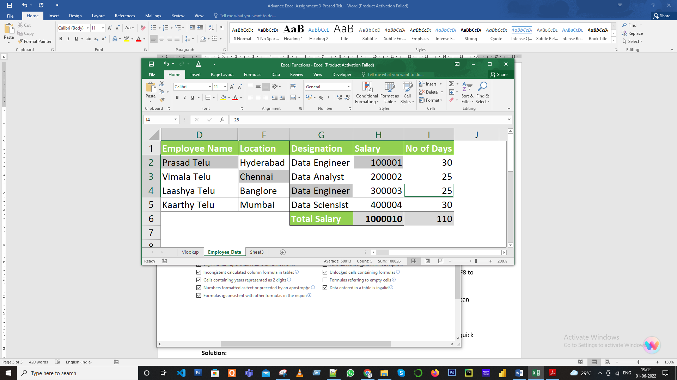

**Using Keyboard**

* Use the keyboard pads or arrow keys to move the cursor to the cell. This will be the active cell.
* Hold down the F8 key. Located at the top of the keyboard. Check the status bar Extend Selection is displayed.
* Use the arrow keys on your keyboard to use individual cells, rows, and columns. Press F8 to Activate advanced selection mode Adjacent cells are automatically selected.
* When the extended selection mode is finished, press and hold at the same time.
* Press the F8 and Shift keys. Now, you are back in Add or Remove Selection mode. You can add cells, delete them, and make other edits.

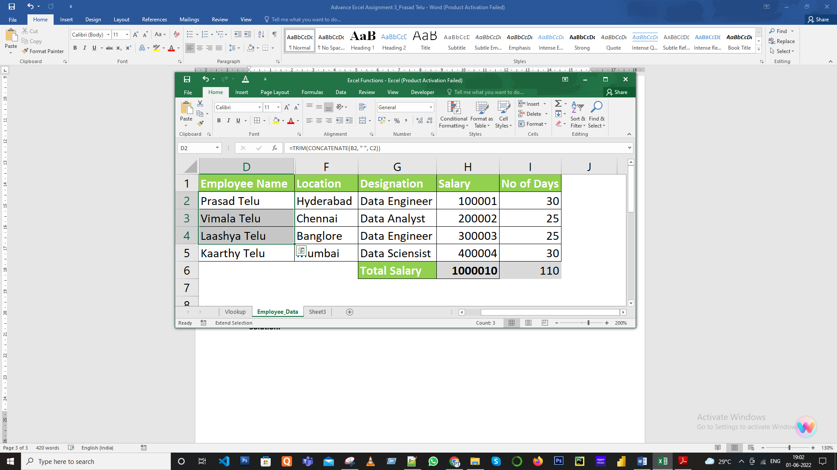

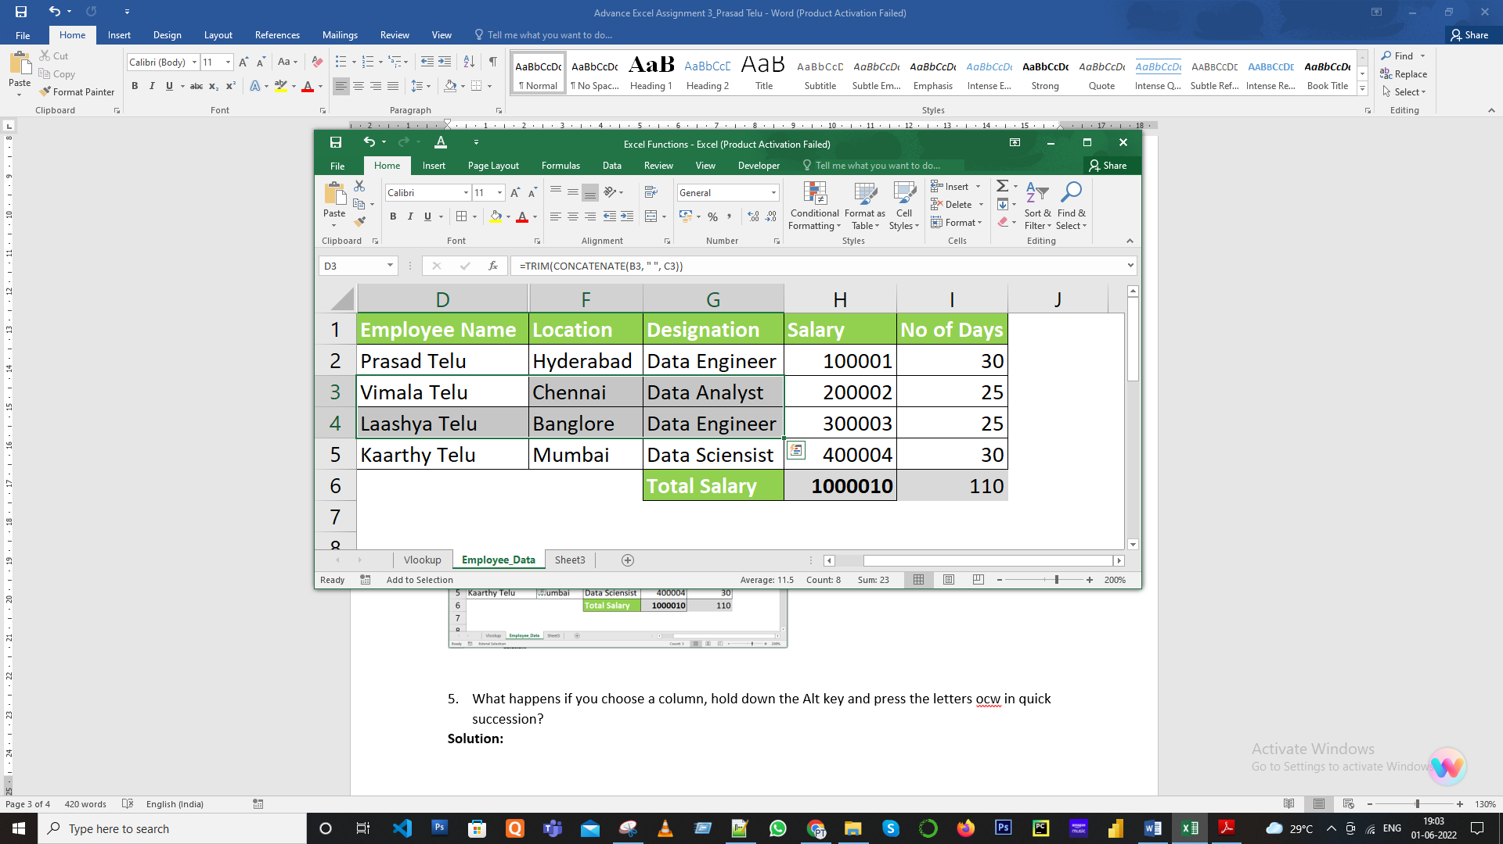

1. What happens if you choose a column, hold down the Alt key and press the letters ocw in quick succession?

**Solution:** Hold the cell andentering the shortcut Alt+O+C+W , will display the column width dialog window

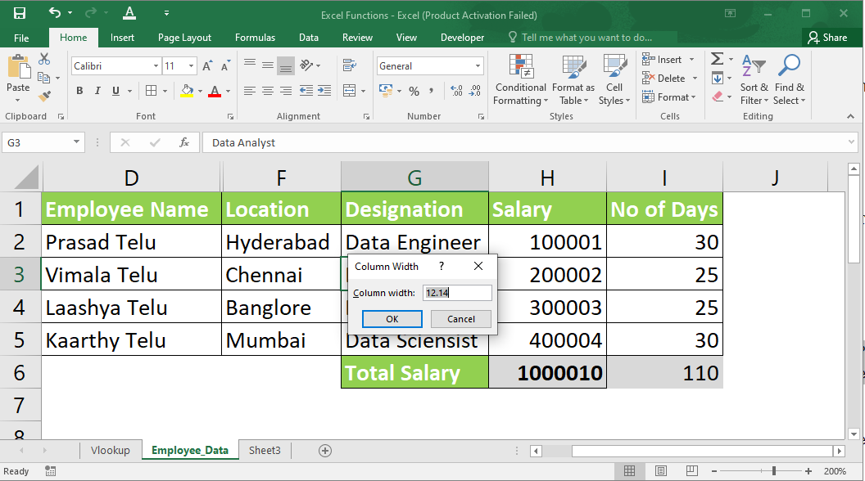

1. If you right-click on a row reference number and click on Insert, where will the row be added?

**Solution:** It will be added on top of the selected row by default. Screenshot below for reference.

